**Steps taken to complete Project 1:**

1. First, I analyzed the given database and different tables in it. I looked for the name of my city and country in city_list table. Then I extracted the required data for project1 using following SQL query and downloaded it as CSV file.

select c.year,

c.avg_temp as city_avg_temp,

g.avg_temp as global_avg_temp

from city_data as c, global_data as g

where c.city ='Boston' and c.country='United States' and c.year = g.year;

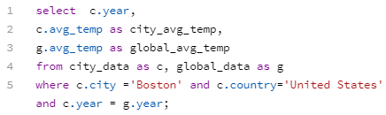

1. I used Microsoft Excel for data analysis in this project.
2. To calculate the moving average, I used Excel’s AVERAGE function. I tried different number of years to calculate moving average as it was not mentioned in the project. I figured out that 10 year moving average gives better line chart which smooths out the volatility in the graph and provide better observation of the long term trends.
3. Line chart showing Boston and Global temperature trends.
4. Observations from above line chart:
5. Boston has been always cooler on average compared to the global temperature.
6. Boston’s average temperature has increased over the period time like the global average temperature.
7. Boston’s average temperature change is positively corelated to the global temperature change with the correlation coefficient = 0.802935176 (calculated using Excel’s CORREL function).
8. Though Boston’s average temperature has increased over the period of time, but the change is not always same as of the global temperature change.
9. Most of the time the rise in Boston’s temperature was less than the global temperature.
10. Except around 1949-1965, when Boston’s average temperature increased as opposed to the average global temperature.
11. Also, the correlation coefficient calculated above can be used to estimate the average temperature in Boston using the average global temperature.
12. Looking at both the local and global trends for last 100 years, we can definitely say that the world is getting hotter.